**VIRTUAL MEMORY**

**Introduction**

* ***Virtual memory*** maintains the execution of multiple processes.
* It allows execution of those programs which are **not** completely in **main memory**.
* This is because some **large programs** may be difficult to be stored in the **main memory** all at once.
* And these programs are stored in form of ***pages***.

**Merits & Demerits of Virtual Memory**

Advantages:-

* Computation speed **increases** when program is executed in small **frames by frames**.
* Used in ***multiprogramming***.
* Can work with **low spaces**.
* More processes can be maintained in the ***main memory***.

Disadvantages:-

* Applications run slow when ***virtual memory*** is running.
* Hard drive space is covered.
* System **stability decreases**.

**Locality of Reference (LOR)**

* **LOR** is an act of accessing **same** pieces of memory locations, by a program.
* To know if a program is using **LOR** or **not**, we have to observe its **subroutine calls & loops**.
* Data or instructions are fetched from ***main memory*** & stored in ***cache***.
* This is done using two methods:
  + ***Temporal locality***
  + ***Spatial locality***

**Temporal Locality**

* The data or instruction being fetched is stored in ***cache***.
* This is done in order to **avoid** searching again & wasting computation time.
* So that when the turn for the data comes to be loaded, it is picked from the ***cache*** rather than being re-searched.

**Spatial Locality**

* In this method, when the data/instruction is being fetched from a memory location, its **surrounding** data/instructions are also loaded along with it.
* This is done in order to **save** computation time.
* More computation time must have been spent in **searching** & **fetching** each data/instruction **individually**.

**Page Fault**

* It is trying to access a page that **doesn’t** exist in main memory.
* ***Valid-invalid bit*** is set to **invalid** when such page is tried accessing.
* **Lazy pager:** Generates page fault.
* Then the OS loads that page from ***secondary memory*** to ***main memory***.

First reference issue:-

* If a ***page*** is referenced for the **first time**, it will be **trapped** & **validation bit** will be set as **invalid**.
* **Trap:** Mechanism to handle **exceptions**.
* So, the ***frame*** becomes **empty** & then again the request is made for that ***page***.
* Now the **validation bit** will be set to **valid**.

**Handling Page Fault**

* **Step 1:** **Check** if the request was made for the right process.
* **Step 2:** If **not**, then **terminate** the process & recall the correct process.
* **Step 3:** Else, find a free ***frame***.
* **Step 4:** A disk operation is **scheduled** to load the required page to that frame.
* **Step 5:** Then our desired page is **loaded** into that frame.
* **Step 6:** And then we **update** process’s internal table & page table.
* **Step 7:** Finally, a **call** is made to that process now.

**Dirty Pages**

* Also known as ***page cache***.
* These are pages which have been **altered** due to some particular data being loaded into the ***main memory***.
* This usually occurs when **changes** are made to files on disk.

**Dirty Bits**

* Also known as ***modified bits***.
* Used for **reducing page faults** & is packed with each page.
* It **detects** if a block of memory is **modified** or **not**.
* **Dirty bit** sets to **1** when it detects so.
* Are used by **CPU cache**.
* If dirty bit of a page is found to be **1**, then that page’s **copy** in ***secondary memory*** is **replaced** by the modified version.

**Paging**

* ***Pages*** can also be defined by being **various divisions** of ***main*** & ***virtual memory***.
* ***Pages*** can be stored either in ***secondary memory*** or ***main memory***.
* In ***secondary memory***, it is stored in frames.
* These ***frames*** need **not** to be necessarily **contagious**.

**Demand Paging**

* The part of the large program that are **loaded** are actually ***pages***.
* It’s difficult to say which pages are required to be loaded into the ***main memory*** and which must stay.
* So, ***demand paging*** method loads only **required pages** into the ***main memory*** & rest must stay where they are.
* **Pager:** Used for swapping ***pages*** in memories.
* ***Demand paging*** has lazy swapping mechanism.
* **Lazy swapper:** **Not** swapping until **not** required.

**Performance of Demand Paging**

Page fault rate:-

* Denoted by **‘p’**.

**0.0 < p < 1.0**

* **0.0** means **no page fault** & **1.0** means **fault in every page**.

Effective access time (EAT):-

**EAT = (1-p) memory access + p (page fault overhead + swap page out + swap page in + restart overhead)**

**Hardware Support**

* Same hardware that is required for ***paging*** & ***swapping***.
* ***Page table*** has the ability to **mark** an entry as **invalid** through ***valid/invalid bit***.
* **Swap space:** A part of ***secondary memory*** specifically used for **swapping** purposes.
* Hence**, *secondary memory*** is also known as ***swap device***.

**No Free Frames Issue**

* If there is **no** free ***frame***, then ***pages*** which are currently **not** in use are **swapped out** by the required ***pages***.
* Then change the respective frames’ ***valid/invalid bit***.
* And this ***frame*** chosen to be replaced with is called ***victim frame***.

**Page Replacement**

* **Swapping in:** Transferring data from ***secondary memory*** to ***main memory***.
* Also known as ***page out***.
* **Swapping out:** Retrieving data back to the ***secondary memory***.
* Also known as ***page in***.

**Page Replacement Algorithms**

***\*The teacher starts licking your paper if you draw flow charts for any algorithm in exams\****

* Deals with **deciding** which ***pages*** are required to be swapped.
* **Efficiency** is decided by the magnitude of **computation time**.
* These algorithms after being **made**, are **tested** & its number of ***page faults*** are **noted**.
* These **test objects** passed for **testing** are known as ***reference strings***.
* And for allowing **enough space** for **testing**, three frames are kept **empty** initially.

**FIFO Page Replacement**

* When a **new *page*** has to be brought up in the memory, it is **replaced** by the **oldest *page*** in the ***main memory***.
* Oldest one means the ***page*** which was brought up first.
* This is implemented by a creating a **queue** for holding ***pages***.

**For example:**

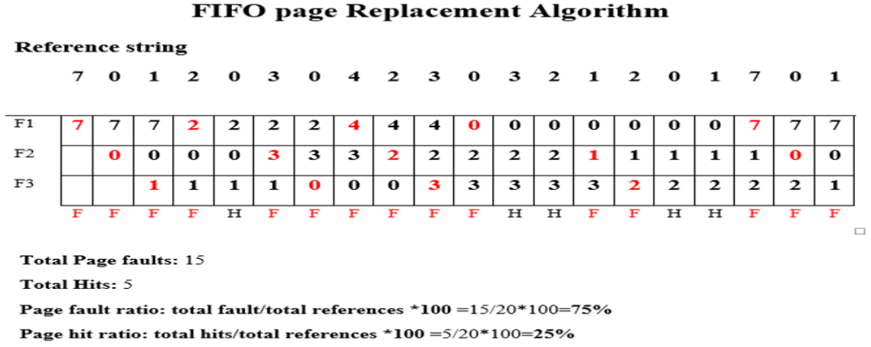

**So, reference strings are passed one-by-one.**

**Each column shows different iterations when each string is passed.**

**If the upcoming string exists in one of frames, then the frames remain unchanged & it is called hit.**

**Else if the string doesn’t exist, it replaces the last brought page & it is called fault.**

**Disadvantages of FIFO Page Replacement**

* A frequently used ***page*** may also get replaced for being brought up the earliest.

**Optimal Page Replacement (OPR)**

* Least ***page fault*** giving replacement technique.
* This is because it **doesn’t** have ***Belady’s Anomaly*** issue.
* **Belady’s Anomaly:** Increased number of ***page faults*** due to high number of ***frames***.
* In ***OPR***, the ***pages*** which **won’t** be used for long time are replaced by **new *pages***.
* It is **more difficult** to implement as we have to make predictions.
* Is **ideal** & **near impossible** to implement.

**For example:**

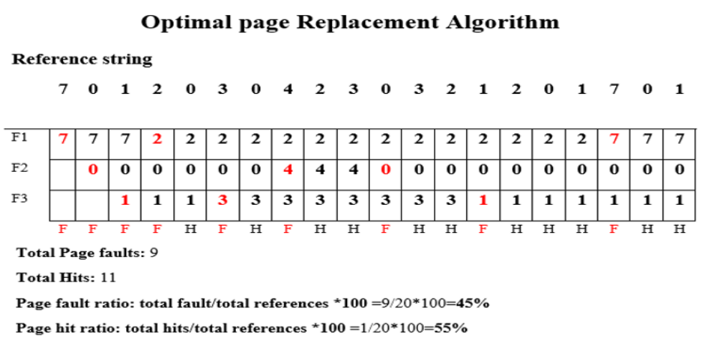

**Least Recently Used Page Replacement (LRU)**

* Replaces ***page*** that was **not** used in recent times.
* So, the page which was in action (brought, replaced or stood same) is not replaced.

**For example:**

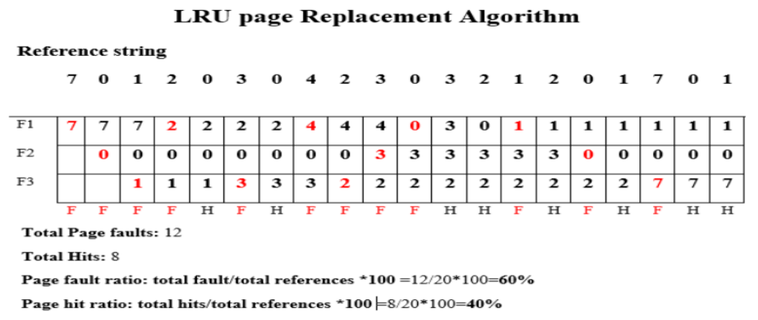

Requirements for LRU implementation:-

* It uses ***reference bits*** to know which ***page*** was referred last.
* **Reference bit:** A bit indicating if a page was **accessed/changed** or **not**.
* The ***reference bit*** for each ***page*** is **zero** initially.

**Not Recently Used Page Replacement (NRU)**

* Recently referred ***pages*** are kept in ***main memory***.
* OS divides pages into **4** **categories**:
  + Referenced, modified
  + Referenced, not-modified
  + Not-referenced, modified
  + Not-referenced, not-modified
* The preference for the categories above is **decreasing** downward.
* A ***page*** is **removed randomly** from the **least** preferred class available.

**Not Frequently Used Page Replacement (NFU)**

* Each ***page*** contains a ***counter*** telling the number of times it has been used.
* The ***page*** with **lowest** counter is **swapped out**.
* This method uses **five** frames generally, unlike others using **three**.